**Outputs Of FOODBOX**

**CAPSTONE PROJECT**

**Screenshots**

* General look of the store:

* Filter the product according to the cuisine

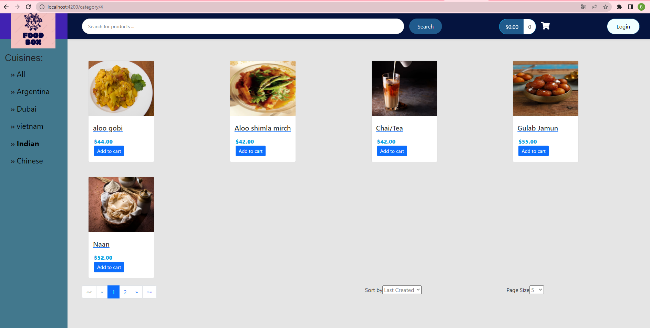

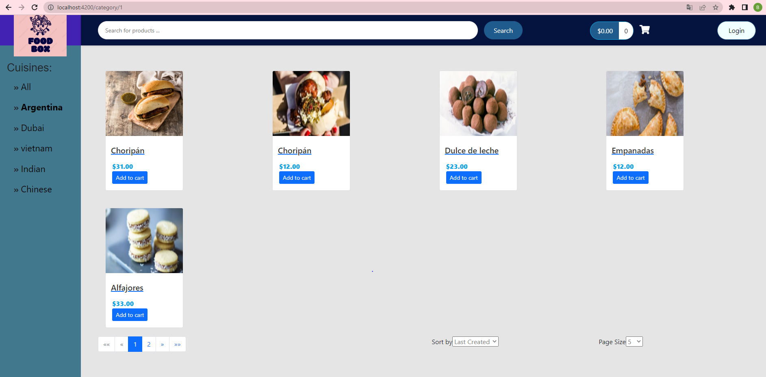

• Filtering by page and sorting are available

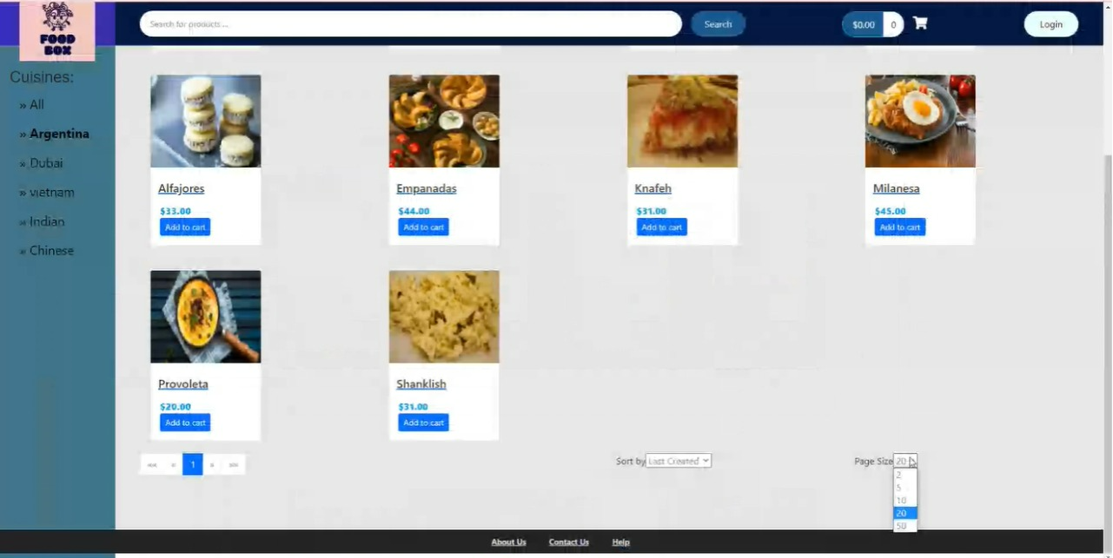

• Sorting can be in one of these three options

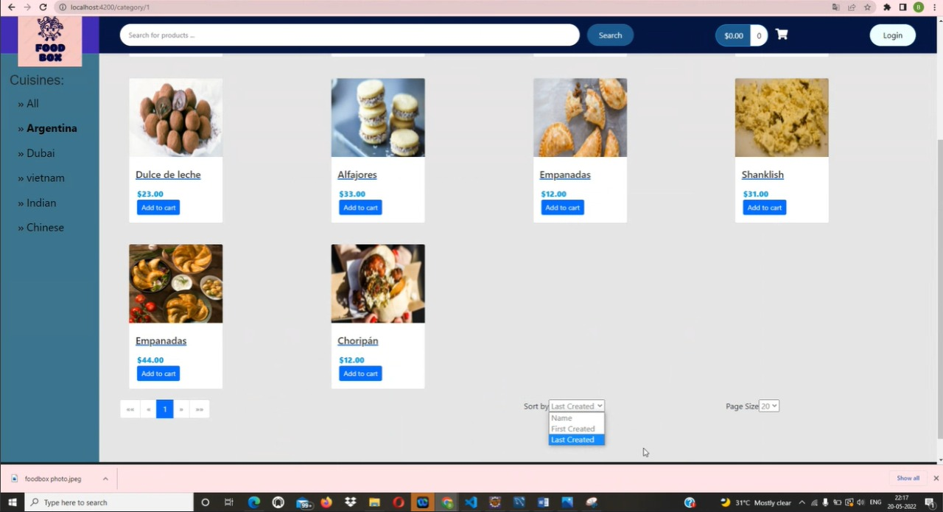

• Sorting by name

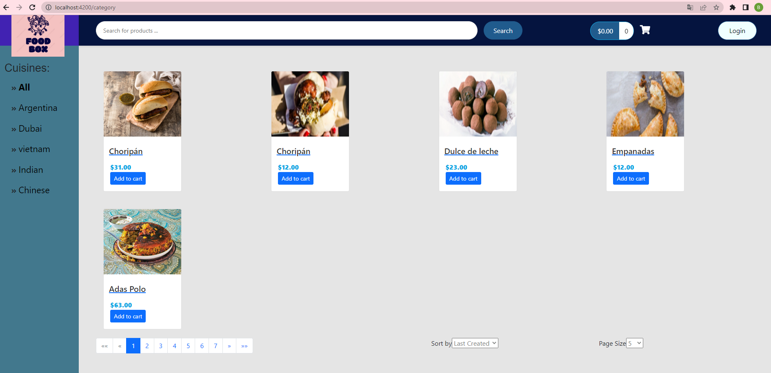

• Choosing the number of each displayed products in each page

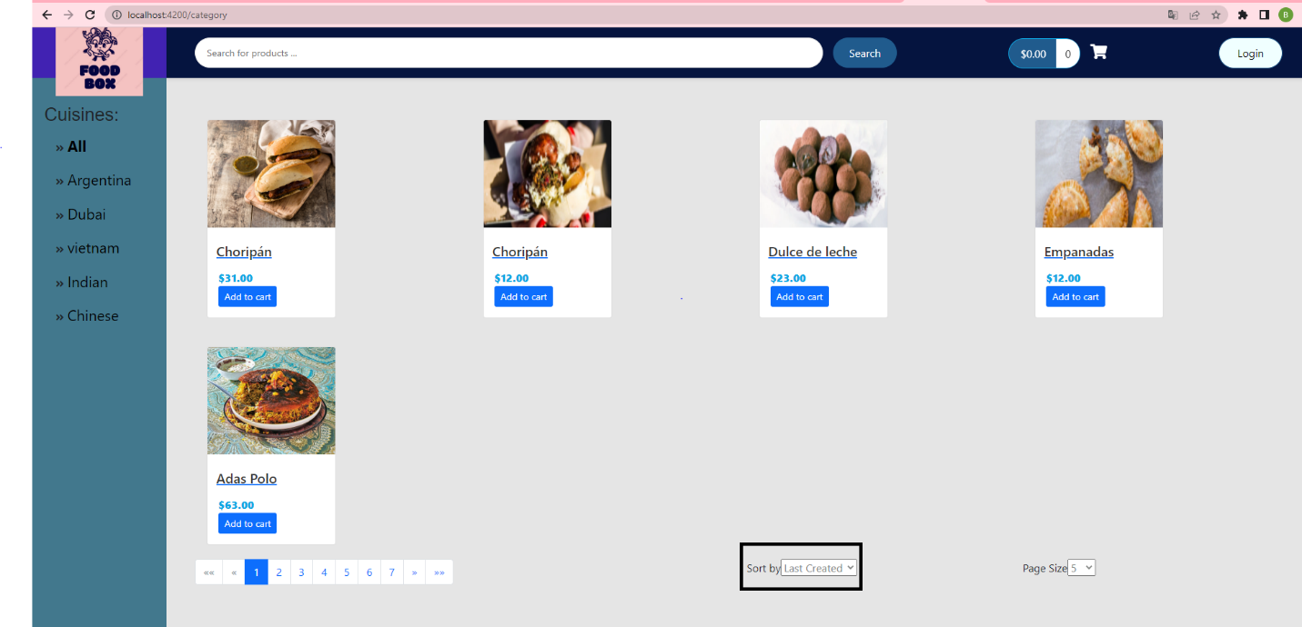

• You can add products to the cart

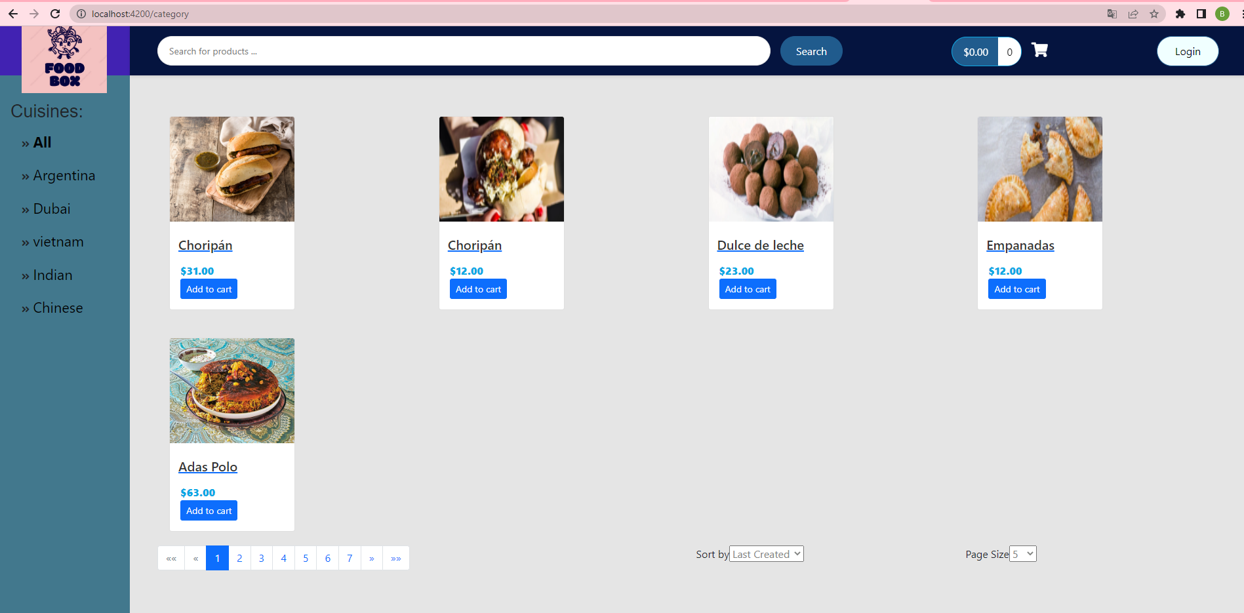

• However, you need to be registered to buy

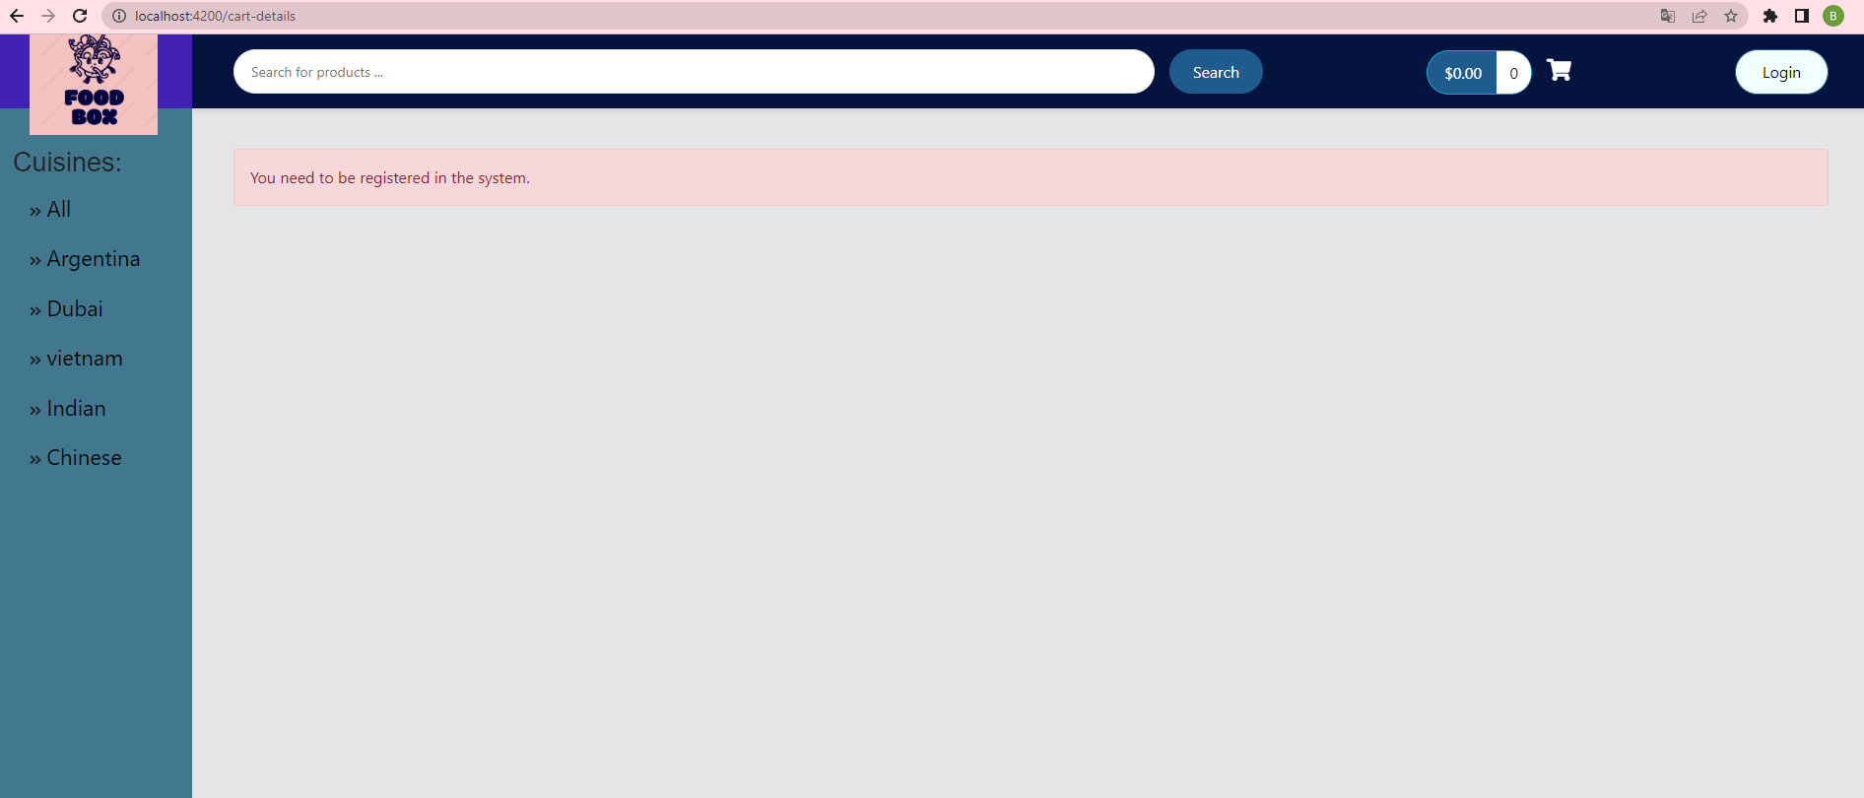

* Login and then create account

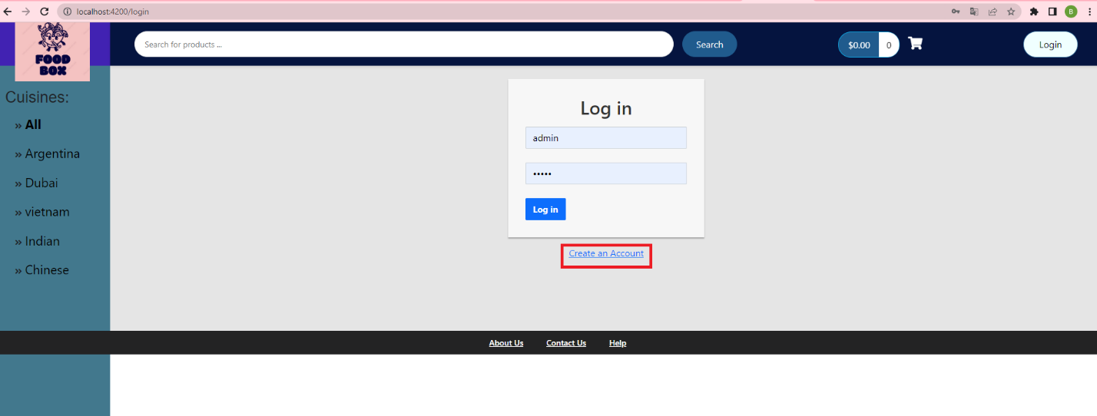

• Register form

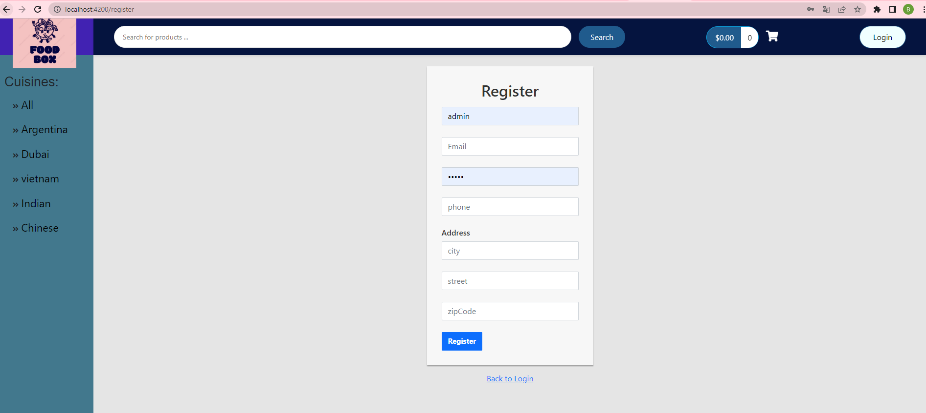

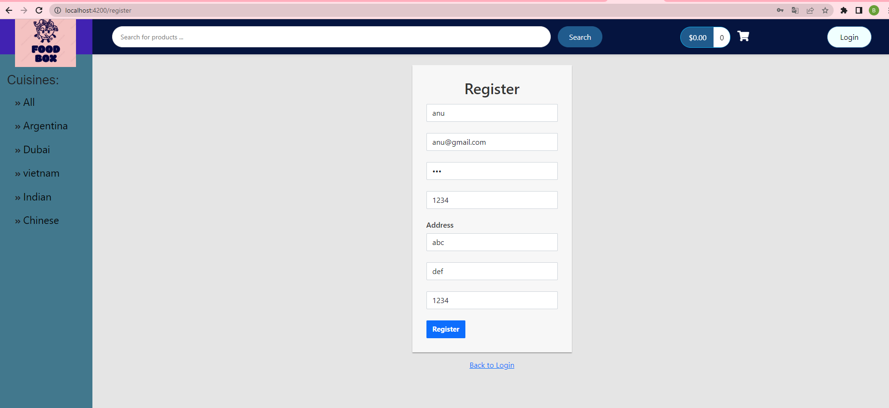

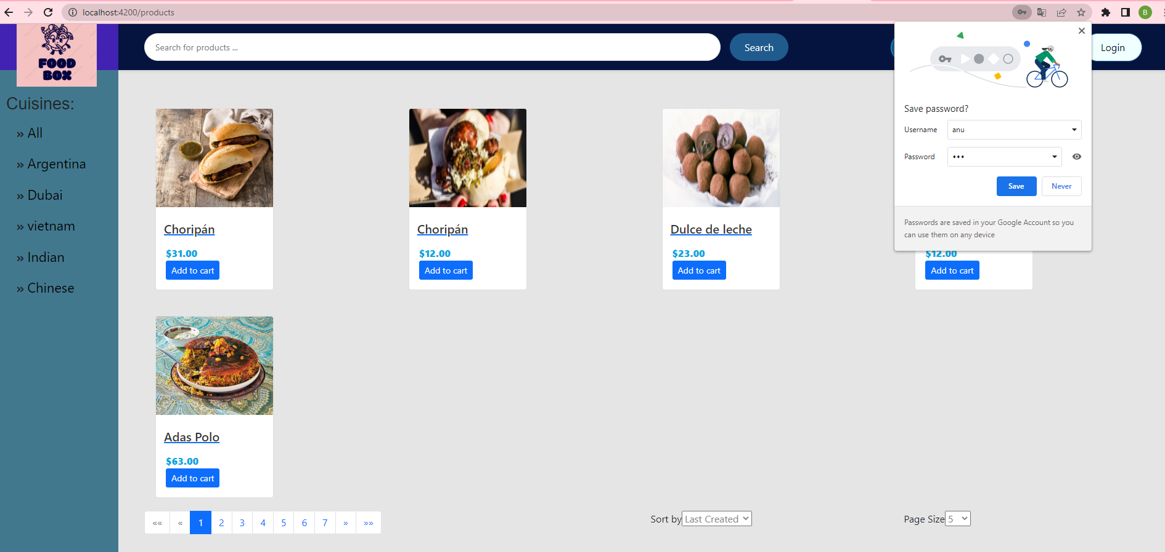

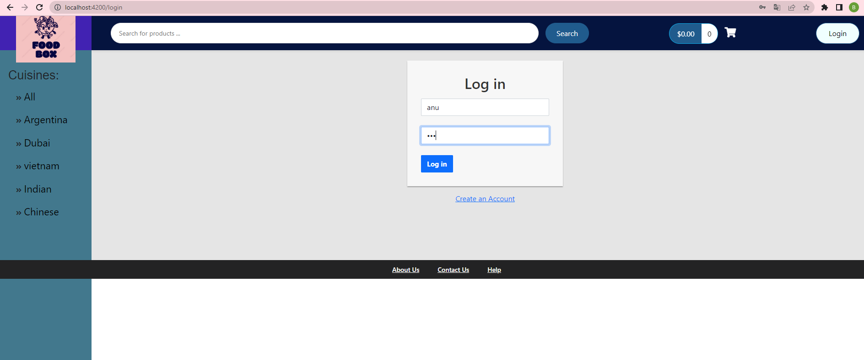

• User logined

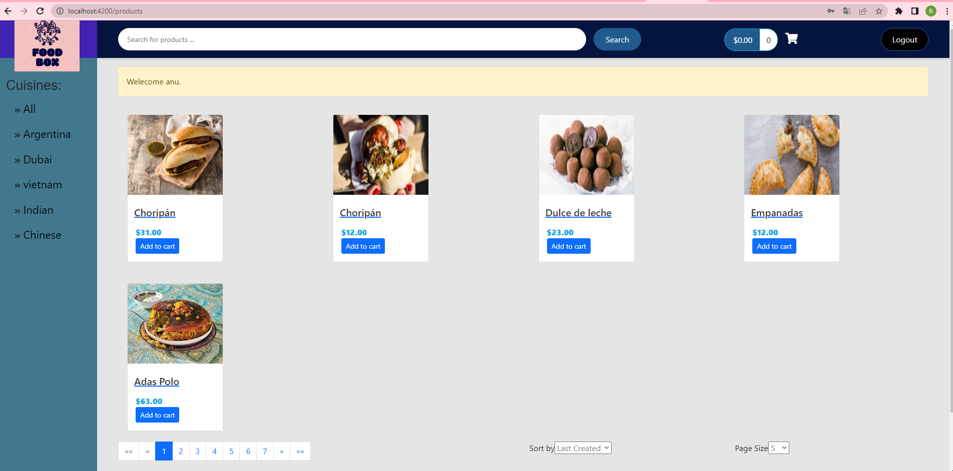

• User can now buy (Payment gateway)

• Can add/remove products during review

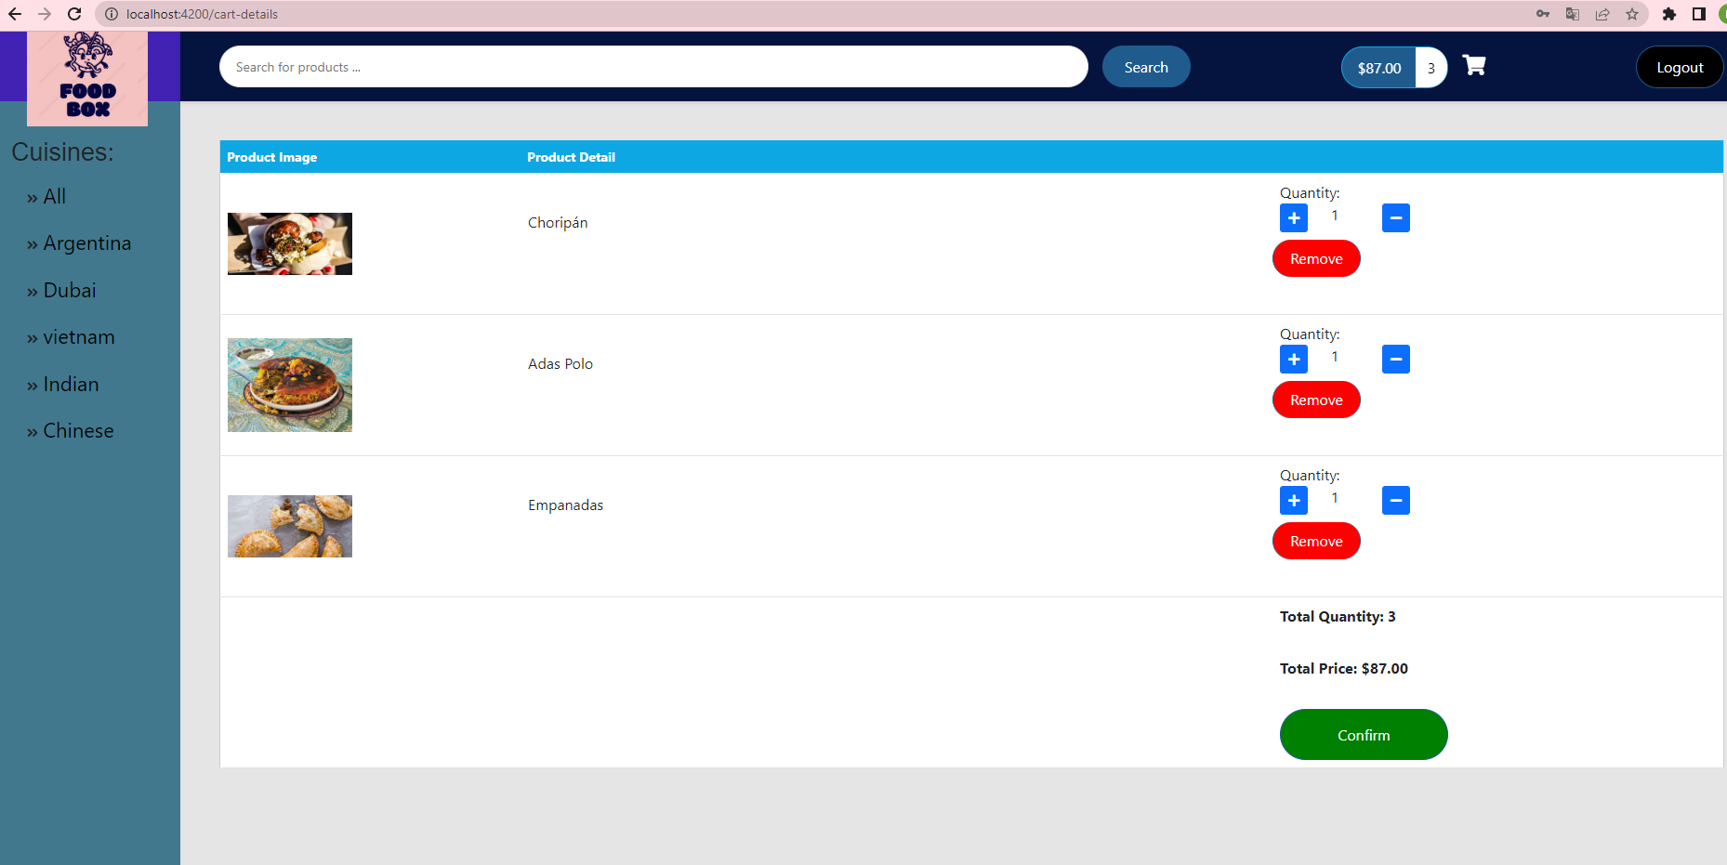

• Check-out and confirm

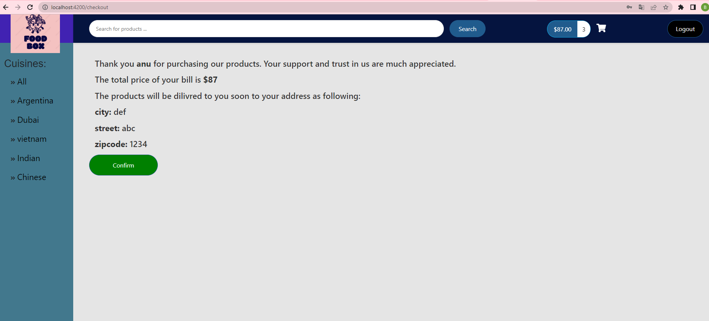

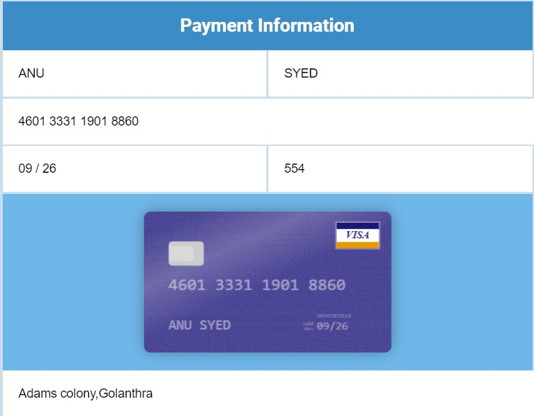

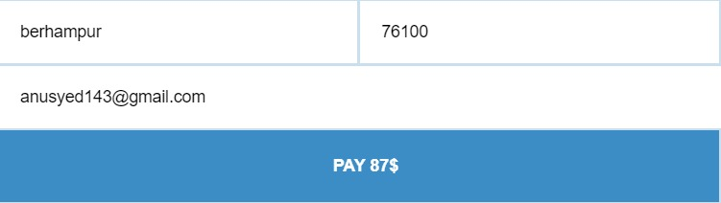

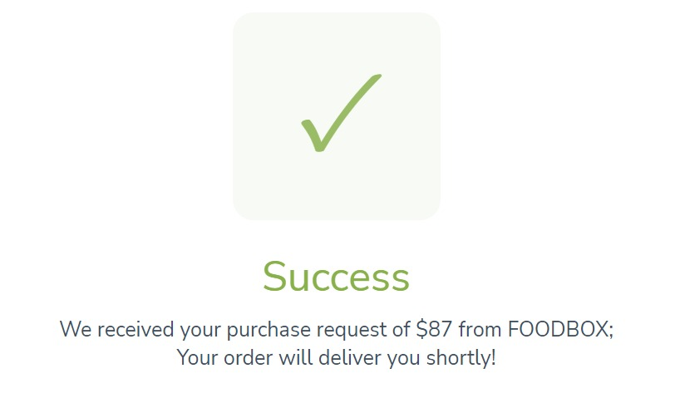

• Search products by Name

• Now, let’s log in as admin

• Admin/admin

• Admin can:

1. Create product

2. Edit product

3. Delete product

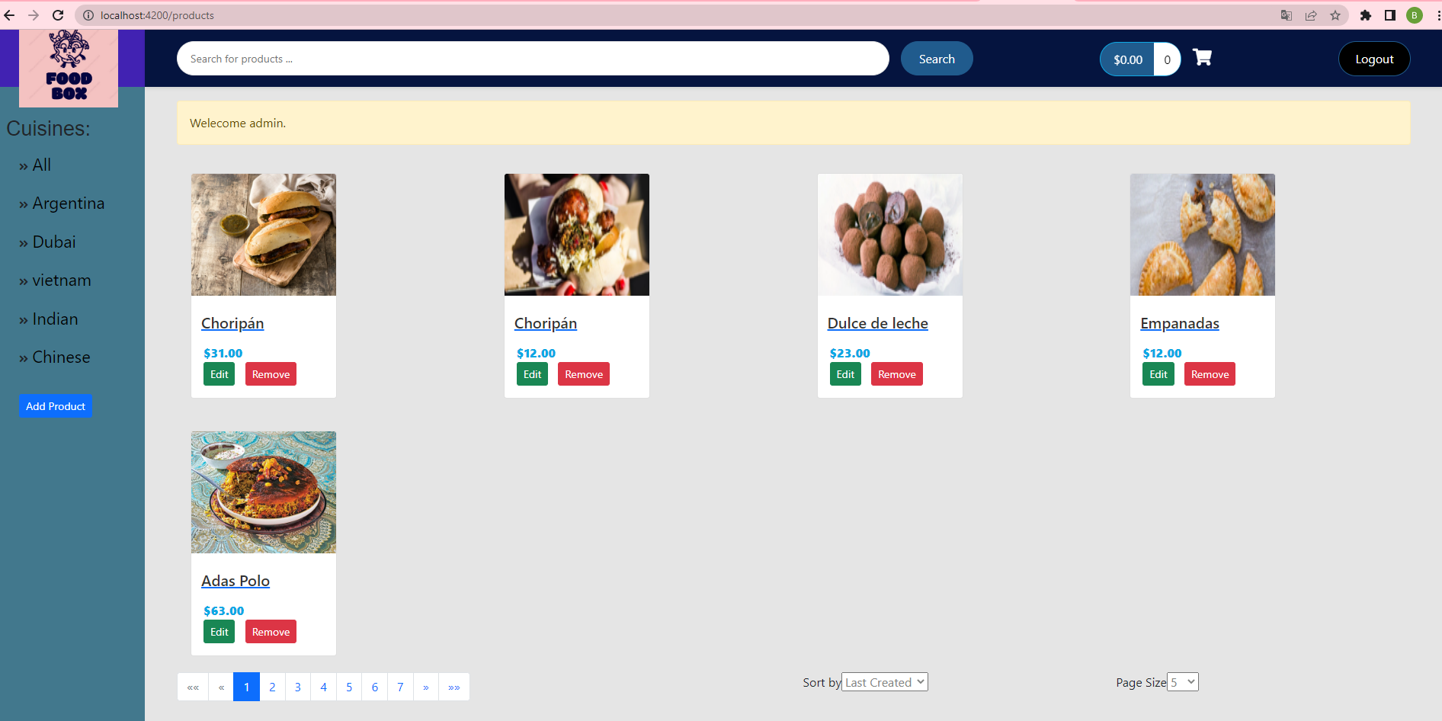

• Create a new product

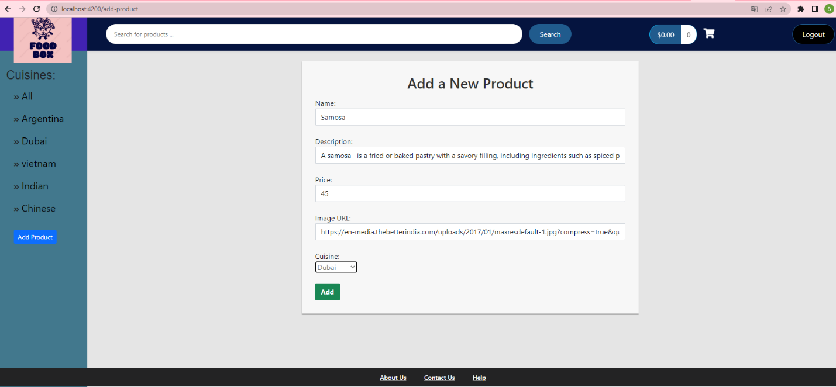

• The new product was added

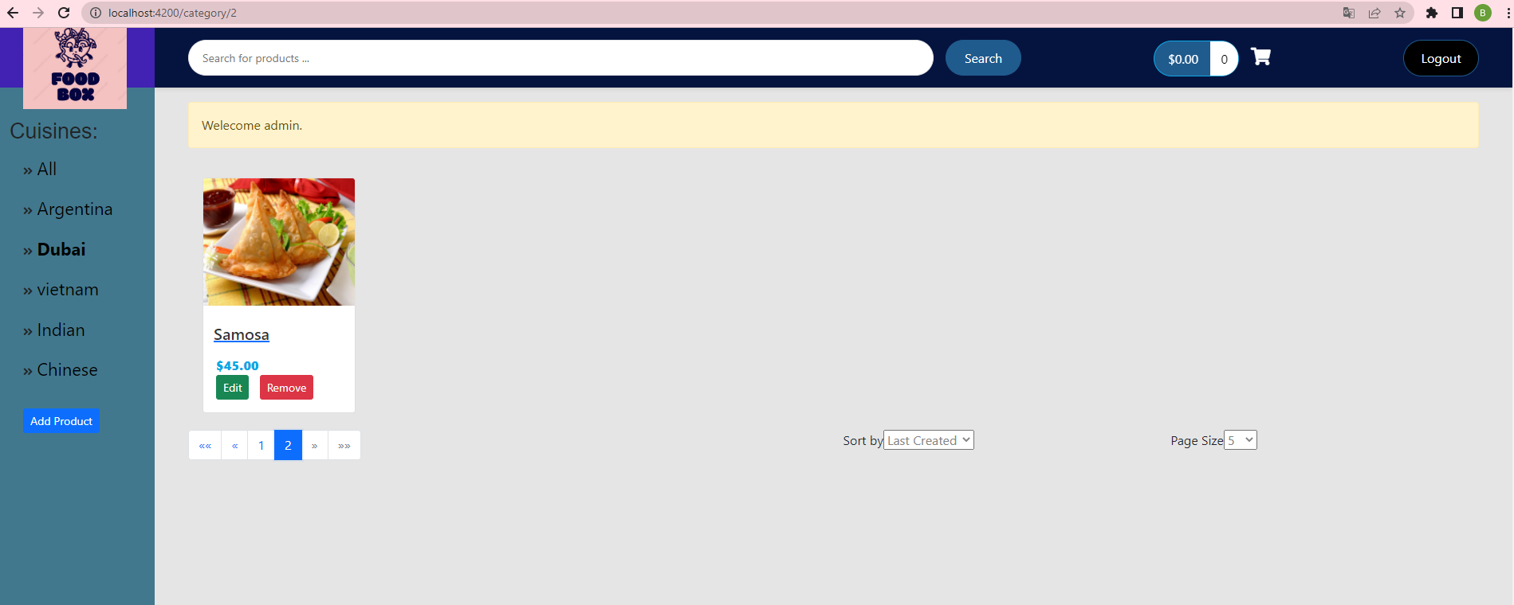

• Let’s update it

• Click Remove to remove it

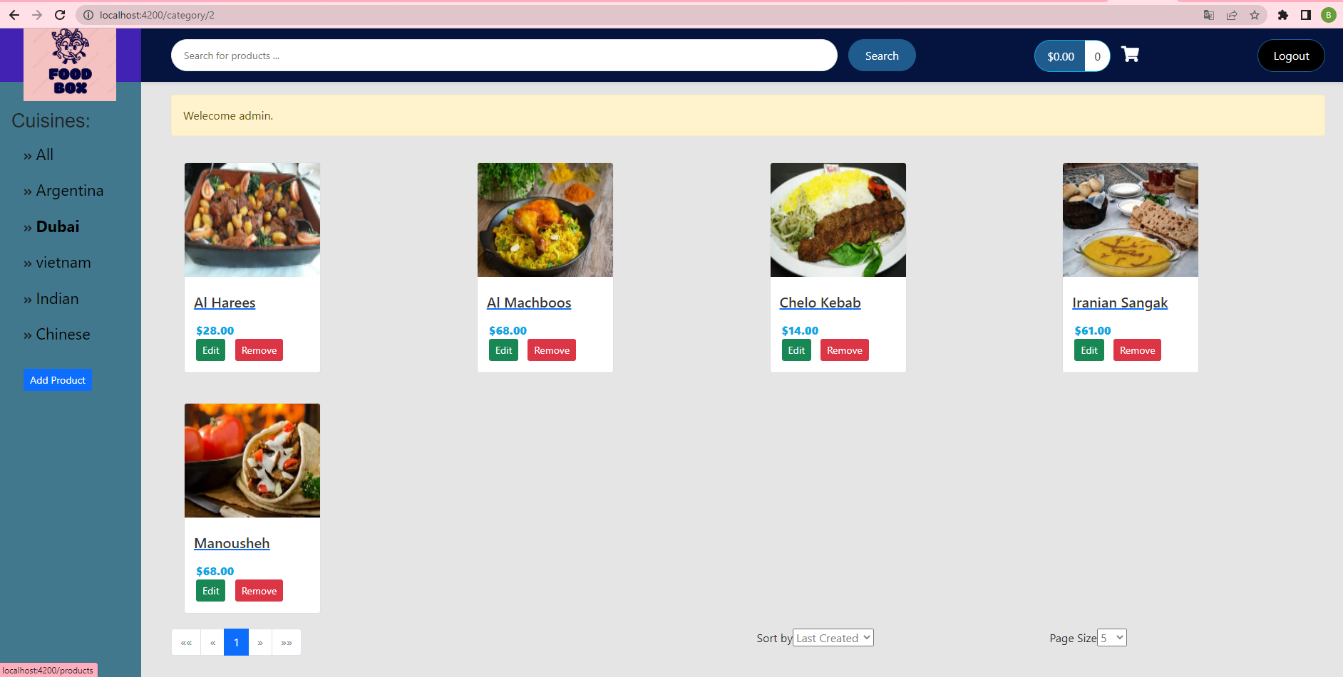

• Deployment

